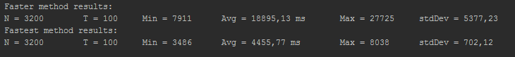

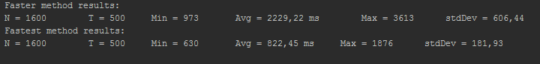

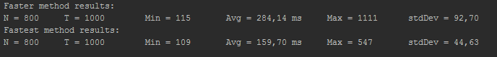

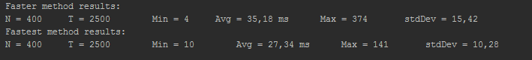

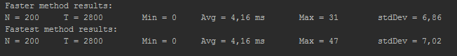

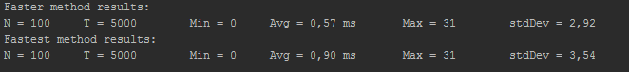

Python Simple:







Java Simple:

